Experiment No. : 2

Title: Divide and Conquer Strategy

Batch: Roll No.: Experiment No.:

Aim: To implement and analyse time complexity of Quick-sort.

Explanation and Working of Quick sort:
QuickSort is a sorting algorithm that works by selecting a pivot element, partitioning the array into two sub-arrays based on the pivot, and recursively sorting each sub-array. The process is repeated until the entire array is sorted in place. QuickSort has an average and best-case time complexity of O(n log n) but can degrade to O(n^2) in the worst case. It is widely used due to its efficiency in practice.

- Input Array: [4, 2, 7, 1, 9, 3]
- Choose Pivot: Choose 4 as the pivot.
- Partitioning:
  - Elements less than 4: [2, 1, 3]
  - Pivot (4): [4]
  - Elements greater than 4: [7, 9]
- Recursion:
  - Apply QuickSort to the left and right sub-arrays.
    - Left sub-array ([2, 1, 3]): [1, 2, 3]
    - Right sub-array ([7, 9]): [7, 9]
- Combine: Concatenate the sorted sub-arrays: [1, 2, 3, 4, 7, 9]
- Final Sorted Array: [1, 2, 3, 4, 7, 9]

Algorithm of Quick sort:

Quick Sort(arr,
low, high):
if low < high:
# Partition the array and get the pivot index
Pivot Index = Partition(arr, low, high)
# Recursively sort the sub-arrays on the left and right of the pivot
Quick Sort(arr, low, pivot Index - 1)
Quick Sort(arr, pivot Index + 1, high)
Partition(arr, low, high):
# Choose a pivot (e.g., the last element)
pivot = arr[high]
# Initialize the index of the smaller element
i = low - 1
# Traverse the array and rearrange elements based on the pivot
for j from low to high - 1:
if arr[j] <= pivot:
# Swap arr[i+1] and arr[j]
Swap(arr, i + 1, j)
i = i + 1
# Swap arr[i+1] and the pivot
Swap(arr, i + 1, high)
# Return the index of the pivot
return i + 1
Swap(arr, i, j):
# Helper function to swap elements at
indices i and j in the array
temp = arr[i]
arr[i] = arr[j]
arr[j] = temp

Derivation of Analysis Quick sort:

Worst Case Analysis
The worst-case scenario for QuickSort occurs when the chosen pivot consistently divides the array into unbalanced sub-arrays, resulting in an unbalanced recursion tree. This can lead to a time complexity of O(n^2).
Derivation:
Suppose, in each recursive call, the pivot always ends up being the smallest or largest
element.
In this case, the partitioning results in one sub-array with n-1 elements and the other
with 0 elements.
The recurrence relation becomes T(n) = T(n-1) + O(n), which leads to O(n^2) time
complexity in the worst case.
Best Case Analysis
The best-case scenario for QuickSort occurs when the chosen pivot consistently
divides the array into approximately equal halves. In the best case, the time
complexity is O(n log n).
Derivation:
If the pivot always divides the array into two equal halves, then in each recursive
call, the size of the problem is halved.
The recurrence relation becomes T(n) = 2T(n/2) + O(n).
By solving this recurrence relation, the time complexity is O(n log n) in the best
case.
Average Case Analysis
On average, QuickSort performs well and has an average-case time complexity of O(n
log n).
Derivation:
The average case assumes that, on average, the pivot divides the array in a
balanced way.
The probability of choosing any element as a pivot is 1/n.
On average, the partitioning process takes linear time O(n).
The average time complexity can be derived by considering all possible choices of
the pivot and taking the expected value.
The recurrence relation becomes T(n) = 2T(n/2) + O(n), leading to O(n log n)
average time complexity.

Program(s) of Quick sort:
import java.util.Scanner;

public class IterativeQuickSort
{
public static void main(String[] args)
{
Scanner scanner = new Scanner(System.in);

System.out.print("Enter the number of elements: ");
int n = scanner.nextInt();

int[] arr = new int[n];

System.out.println("Enter the elements:");
for (int i = 0; i < n; i++)
{
arr[i] = scanner.nextInt();
}

System.out.println("Original Array:");
printArray(arr);

int iterations = iterativeQuickSort(arr);

System.out.println("\nSorted Array:");
printArray(arr);

System.out.println("\nNumber of Iterations: " + iterations);
}

public static int iterativeQuickSort(int[] arr)
{
int low = 0;
int high = arr.length - 1;
int iterations = 0;

while (low < high)
{
int pivotIndex = partition(arr, low, high);
if (pivotIndex - low < high - pivotIndex)
{
iterativeQuickSortHelper(arr, low, pivotIndex - 1);
low = pivotIndex + 1;
}
else
{
iterativeQuickSortHelper(arr, pivotIndex + 1, high);
high = pivotIndex - 1;
}

iterations++;
}

return iterations;
}

public static void iterativeQuickSortHelper(int[] arr, int low, int high)
{
while (low < high)
{
int pivotIndex = partition(arr, low, high);
if (pivotIndex - low < high - pivotIndex)
{
iterativeQuickSortHelper(arr, low, pivotIndex - 1);
low = pivotIndex + 1;
}
else
{
iterativeQuickSortHelper(arr, pivotIndex + 1, high);
high = pivotIndex - 1;
}
}
}

public static int partition(int[] arr, int low, int high)
{
int pivot = arr[high];
int i = low - 1;

for (int j = low; j < high; j++)
{
if (arr[j] <= pivot)
{
i++;
swap(arr, i, j);
}
}

swap(arr, i + 1, high);
return i + 1;
}

public static void swap(int[] arr, int i, int j)
{
int temp = arr[i];
arr[i] = arr[j];
arr[j] = temp;
}

public static void printArray(int[] arr)
{
for (int num : arr)
{
System.out.print(num + " ");
}
System.out.println();
}
}
Output(o) of Quick sort:
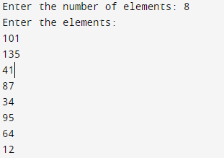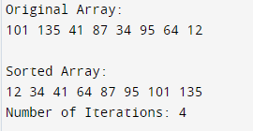

Results:

Time Complexity of Quick sort:

Worst Case Analysis:

Sr. No. | Input size | No: of steps from Algorithm analysis | No: of steps from Theoretical analysis
1. | 1000 | 499500 | 6907
2. | 10000 | 49995000 | 92103
3. | 20000 | 199990000 | 198069
4. | 30000 | 449985000 | 309268

GRAPH:

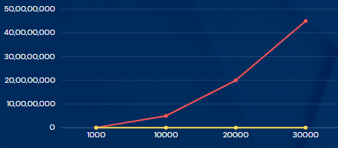

Best Case Analysis:

Sr. No. | Input size | No: of steps from Algorithm analysis | No: of steps from Theoretical analysis
1. | 1000 | 10676 | 6907
2. | 10000 | 158562 | 92103
3. | 20000 | 339756 | 198069
4. | 30000 | 542423 | 309268

GRAPH

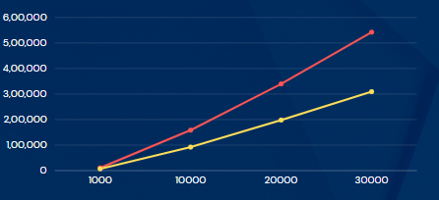

Conclusion: (Based on the observations):
We understood how quick sort works and how the different time complexities work.

Outcome:
CO1 Analyze time and space complexity of basic algorithms.

References:
- Richard E. Neapolitan, " Foundation of Algorithms ", 5th Edition 2016, Jones & Bartlett Students Edition
- Harsh Bhasin , " Algorithms : Design & Analysis", 1st Edition 2013, Oxford Higher education, India
- T.H. Coreman ,C.E. Leiserson,R.L. Rivest, and C. Stein, " Introduction to algorithms", 3rd Edition 2009, Prentice Hall India Publication
- Jon Kleinberg, Eva Tardos, " Algorithm Design", 10th Edition 2013, Pearson India Education Services Pvt. Ltd.

